CSP554—Big Data Technologies

Assignment #6 (Modules 06)

Worth: 12 points (2 points for each problem)

Due by the start of the next class period
Assignments can be uploaded via the Blackboard portal
It is ok to ask for hints from me to help solve the problems below. I will try to be helpful without giving away the answers.
Note: There may be short quiz questions about readings, assignments or articles (except extra credit) in the class period when they are due.
Read from:
- Spark SQL: Relational Data Processing in Spark (in Blackboard “Articles” folder)
- Spark SQL and DataFrames (in Blackboard “Free Books and Chapters” folder)
For this assignment you will be using your Hadoop environment including the pyspark CLI.
Exercise 1)
TestDataGen
Use the TestDataGen program from previous assignments to generate a new foodratings<magic_number>.txt data file.
Copy the file to HDFS, say into the /user/maria_dev directory.
Read in the text file into an RDD named ex1RDD.
This RDD should now have records each consisting of a single string having 6 comma-separated parts something like the following:
u'Joe,44,33,41,1,5'
u'Mel,13,33,30,50,6'
u'Mel,12,40,30,42,1'
u'Sam,15,28,28,39,2'
List the first five records of the RDD using the “take(5)” action and copy them and the “magic number to your assignment submission for this exercise.
Command:
Magic Number = 183081
>>> ex1RDD=sc.textFile('/user/maria_dev/foodratings183081.txt');
>>> ex1RDD.take(5);
[u'Sam,32,5,34,35,1', u'Jill,10,48,8,45,5', u'Sam,23,15,21,33,3', u'Sam,38,7,27,22,4', u'Sam,2,39,31,42,5']
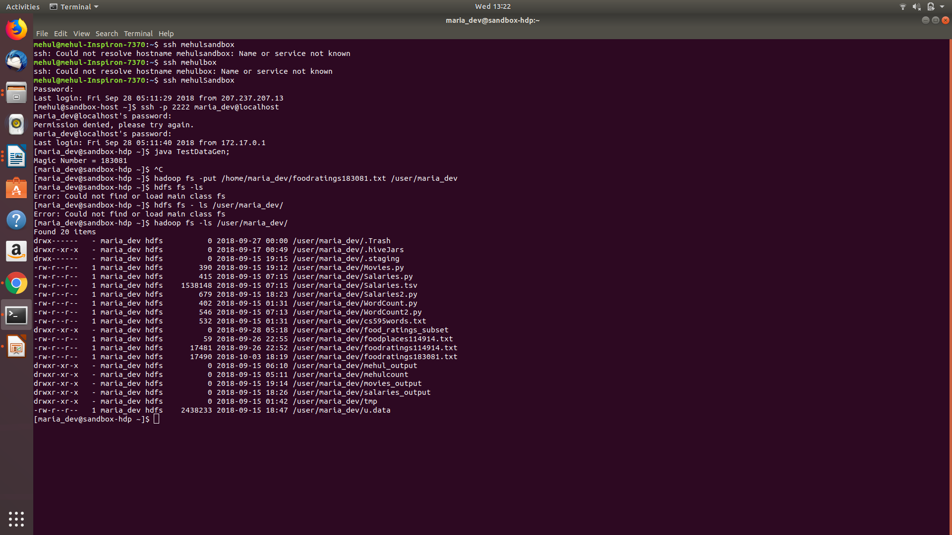
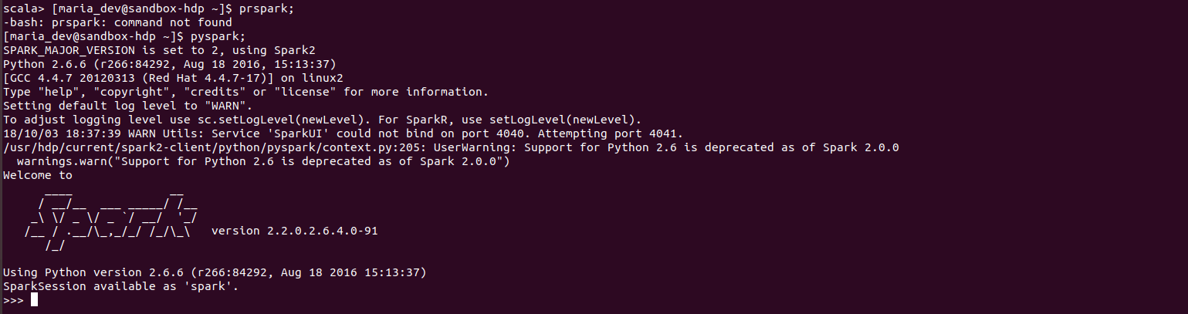
Exercise 2)
Create another RDD called ex2RDD where each record of this new RDD has 6 fields, each a string, by splitting apart each record on “,” boundaries from the ex1RDD.
The records of the new RDD should look something like:
u'Joe', u'44', u'33', u'41', u'1‘, u’5’
u‘Mel', u'13', u'33', u'30', u'50, u’6’‘
u‘Mel', u'12', u'40', u'30', u'42‘, u’1’
u'Sam', u'15', u'28', u'28', u'39‘, u’3’
List the first five records of this RDD using the “take(5)” action and copy them to your assignment submission for this exercise.
Command:
>>> ex2RDD=ex1RDD.map(lambda ex1RDD: ex1RDD.split(","));
>>> ex2RDD.take(5);
[[u'Sam', u'32', u'5', u'34', u'35', u'1'], [u'Jill', u'10', u'48', u'8', u'45', u'5'], [u'Sam', u'23', u'15', u'21', u'33', u'3'], [u'Sam', u'38', u'7', u'27', u'22', u'4'], [u'Sam', u'2', u'39', u'31', u'42', u'5']]
Exercise 3)
Create another RDD called ex3RDD from ex2RDD where each record of this new RDD has its third column converted from a string to an integer.
The records of the new RDD should look something like:
u'Joe', u'44', 33, u'41', u'1‘, u’1’
u‘Mel', u'13', 33, u'30', u'50‘, u’2’
u‘Mel', u'12', 40, u'30', u'42‘, u’3’
u'Sam', u'15', 28, u'28', u'39‘, u’4’
Hint: Use a lambda function something like the following:
lambda line : [line[0], line[1], int(line[2]), line[3], line[4], line[5]]

List the first five records of this RDD using the “take(5)” action and copy them to your assignment submission for this exercise.
Command :
>>> ex3RDD=ex2RDD.map(lambda line:[line[0],line[1],int(line[2]),line[3],line[4],line[5]]);
>>> ex3RDD.take(5);
[[u'Sam', u'32', 5, u'34', u'35', u'1'], [u'Jill', u'10', 48, u'8', u'45', u'5'], [u'Sam', u'23', 15, u'21', u'33', u'3'], [u'Sam', u'38', 7, u'27', u'22', u'4'], [u'Sam', u'2', 39, u'31', u'42', u'5']]
Exercise 4)
Create another RDD called ex4RDD from ex3RDD where each record of this new RDD is allowed to have a value of < 25 for its third field.
The records of the new RDD should look something like:
u'Joe', u'44', 21, u'41', u'1‘, u’6’
u‘Mel', u'13', 3, u'30', u'50‘, u’1’
u‘Mel', u'12', 4, u'30', u'42‘, u’4’
u'Sam', u'15', 8, u'28', u'39‘, u’5’
List the first five records of this RDD using the “take(5)” action and copy them to your assignment submission for this exercise.
Command :
>>> ex4RDD = ex3RDD.filter(lambda line: int(line[2] < 25));
>>> ex4RDD.take(5);
[[u'Sam', u'32', 5, u'34', u'35', u'1'], [u'Sam', u'23', 15, u'21', u'33', u'3'], [u'Sam', u'38', 7, u'27', u'22', u'4'], [u'Joe', u'22', 14, u'16', u'23', u'4'], [u'Joy', u'39', 23, u'26', u'23', u'1']]
Exercise 5)
Create another RDD called ex5RDD from ex4RDD where each record is a key value pair where the key is the first field of the record and the value is the entire record
The records of the new RDD should look something like:
(u’Joe’, (u'Joe', u'44', 21, u'41', u'1‘, u’1’))
(u’Mel’, (u‘Mel', u'13', 3, u'30', u'50‘, u’6’))
List the first five records of this RDD using the “take(5)” action and copy them to your assignment submission for this exercise.
Command:
ex5RDD = ex4RDD.map(lambda line:(line[0],line));
ex5RDD.take(5);
Exercise 6)
Create another RDD called ex6RDD from ex5RDD where the records are organized in ascending order by key
The records of the new RDD should look something like:
(u’Joe’, (u'Joe', u'44', 21, u'41', u'1‘, u’4’))
(u’Mel’ , (u‘Mel', u'13', 3, u'30', u'50‘, u’3’))
(u’Sam’ , (u‘Sam', u'23', 3, u'40', u'20‘, u’7’))
List the first five records of this RDD using the “take(5)” action and copy them to your assignment submission for this exercise.
Command :
>>> ex6RDD = ex5RDD.sortByKey(True);
>>> ex6RDD.take(5);
[(u'Jill', [u'Jill', u'30', 21, u'1', u'13', u'5']), (u'Jill', [u'Jill', u'43', 10, u'30', u'16', u'3']), (u'Jill', [u'Jill', u'20', 22, u'14', u'22', u'1']), (u'Jill', [u'Jill', u'44', 16, u'47', u'30', u'1']), (u'Jill', [u'Jill', u'4', 23, u'12', u'47', u'5'])]

